Fully Automatic Round Bottle Labeling Machine
Equipment Operation Manual

Please read this manual carefully before use this equipment

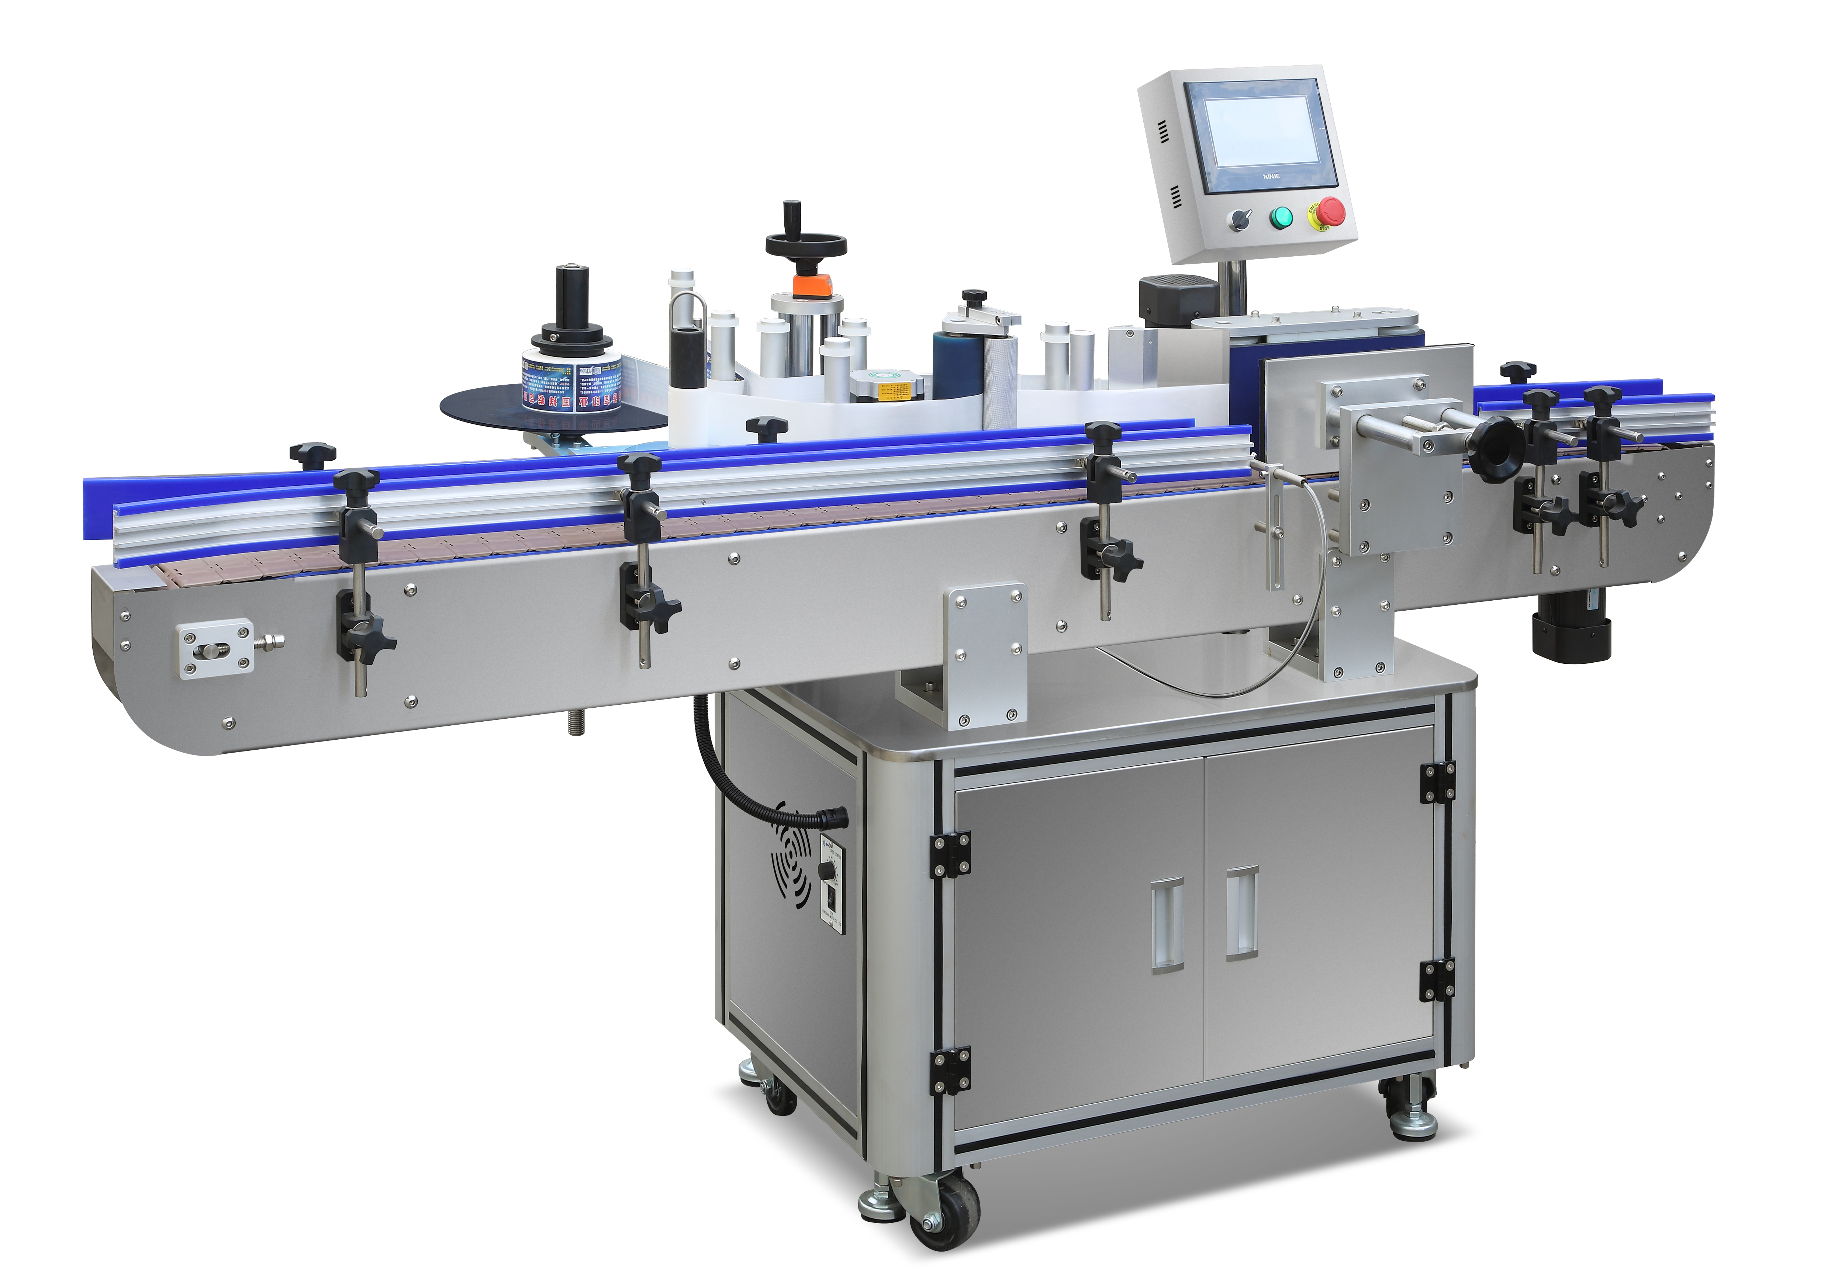

Contents

Part 1 Product introduction·························3
Part 2 Product power and capacity scale···················3
Part 3 Equipment working principle·····················3
Part 4 Check before start ·······················4
Part 5 Touch screen button function and switch ················4
Part 6 Labeling device method ·····················5
Part 7 Overall top view of equipment ····················6
Part 8 Equipment operation and simple adjustment···············7
Part 9 Japan's Panasonic digital optical fiber sensor sensitivity adjustment method···8
Part 10 Circuit wiring diagram·······················8
Part 11 Common problem and solution····················10
Part 12 Equipment maintenance ······················11
Part 13 Equipment main configuration list···················11

Part 1 Product introduction
Fully automatic round bottle labeling machine which mainly built up by host, supplying standard, pulling standard, conveying, receiving paper, induction drive. This equipment original technique from Taiwan. After redesign and based on original technique, we use equipment overall work principle better. During production, operation become more easier, accuracy and stability become higher which make equipment use scale more wide. This equipment not only complete work independently but also combine work with other equipment. Despite standard production, the equipment can be enlarged, widened and lengthened according to customer requirement. It can also be customized according to special-shaped products and fixed-point positioning of certain products.

Part 2 Product power and capacity scale
Voltage： AC110V 60HZ
Power： 1hour ≤1kw
Capacity： 1-50bottle/min（speed can be adjusted according to product diameter）
Labeling accuracy： ±1mm（Depend on the overall and flatness of the product）
Adapt to the product range：Diaφ20-φ100 mm（Special order is required outside the size）
Pass rate： over ≥99%
Dimension： 2000X1050X1250 mm（length X wide X height）
Weight： ≤170KG

Part 3 Equipment working principle
Automatic bottle labeling machine complete label according to principle of Rotary Extrusion.When the product runs on the conveyor belt to between the spokes and the spoke baffles, the product detection photoelectric sensor is triggered to give a start signal, and the main traction motor runs to peel off the label backing paper and pass the labeling set in the system Delay the labeling on the product. When the gap between the label and the label passes the label detection sensor, the label detection sensor automatically gives a stop signal. At this time, a labeling cycle is completed, and so on and off to complete all labeling output.

Part 4 Check before start
- First, place the equipment on overall level field, and hold 4 legs tightly.
- Check the location of power supply device which inside the equipment, and see if it is
a 3-hole socket, well grounded and if the voltage AC220V.
- Check the electrical box inside equipment. During the transportation, whether the relay loose, whether the optical fiber of the sensor is loose and whether the screws of the photoelectric bracket are tightened.
- Check whether the overall shape of the device is bruised, whether any screws have fallen loose during the shipment, and manually shake the motherboard back and forth to see if it is shaking.

Part 5 Touch screen button function and switch
(一) Emergency stop switch and power switch
After finished equipment examination, put plug in the power cord and press the button marked as power switch on the switch box which in the left of conveyor belt. At this time, the power indicator light in the middle of the switch box lights up and is blue (green). The touch screen lights up, and the exhaust fan on side 2 of the chassis is running. The emergency stop switch is used for emergency shutdown during equipment production.

（二）Host touch screen interface buttons (Interface Figure 1)
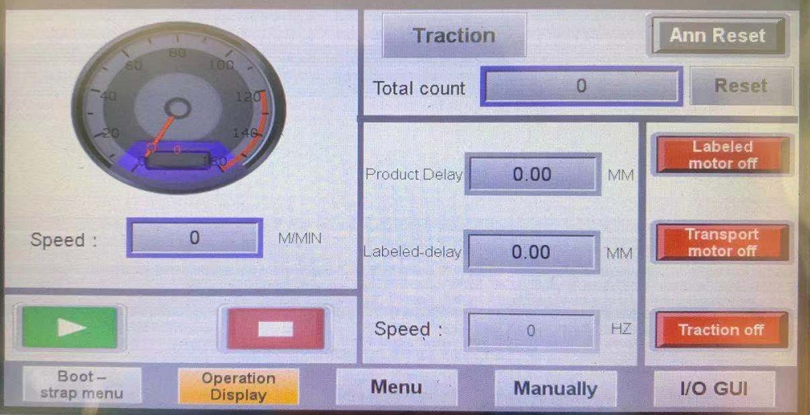

（三）Button function
- Start/stop A switch used to start or stop the operation of the equipment.
- Transfer speed Conveyor motor speed regulator is used to control the switch of the conveyor belt running speed.
- Label location It is used to control the parameters of label length by adjusting the position of the sensor probe. (Generally speaking, the length of the label should be 3-5 mm away from the opening of the peeling plate)
- Label delay The function is to give the labeling signal to the system when the product detects the photoelectric induction to the product. After the system receives the signal, how long does it take to let the labeling motor run. (That is, the adjustment before and after the labeling position)
- Production delay The function is to give the labeling signal to the system when the production detects the photoelectric induction to the product. After the system receives the signal, how long does it takes to let the labeling motor run. （that is , the adjustment before and after the labeling position)
- Label counting The number of stickers is used to count the production output. （1-99999）
- Clear count It is used to clear the current statistical output and reset it to zero.

Part 6 Labeling device method：（Figure 1）
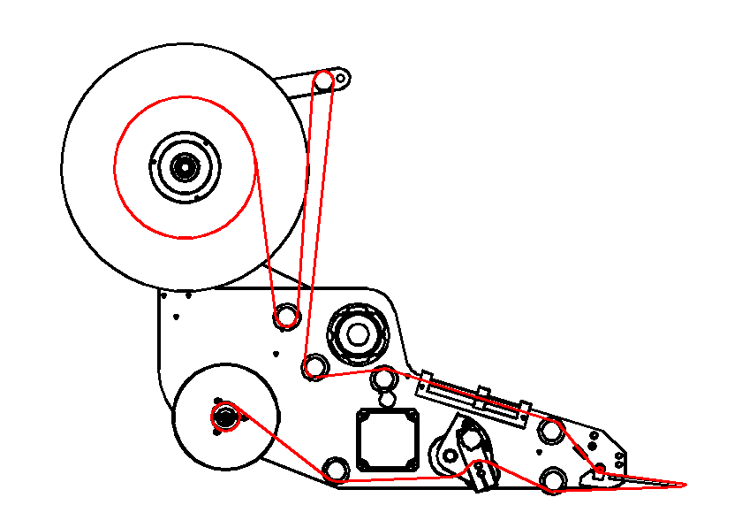

Part 7 Overall top view of equipment （figure 2）
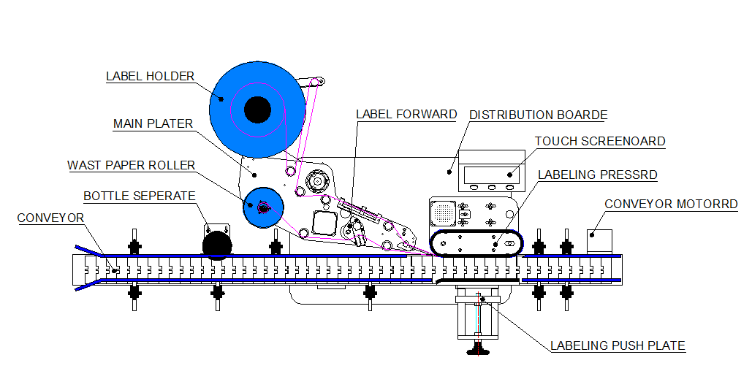

- supply device:Acrylic material, label placement platform for winding machine.
- Paper delivery device:Acrylic material, label waste paper collection device.
- Main mounting plate:Aluminum alloy material, its function is to install all labeling devices. The mechanism including the traction roller, the guide roller, the label supply device, the paper delivery device and the position adjustment of the main mounting board are all installed on the main board.
- touch screen:The main parts of the labeling system are connected to the PLC data inside the chassis, and its function is to control all labeling actions, including production output and labeling signals.
- Equipment case: It is composed of aluminum alloy and other materials, including the labeling tape (140X725 specification), the labeling motor (1:15 90W geared motor with speed regulator) and the labeling mounting plate and other important mechanisms. Its main function is to make the product rotate and label .
- Transfer motor: 1:15 120W decelerating motor with speed regulator, the main function is to run the conveyor belt.
- Override baffle:It is composed of aluminum alloy and other materials, and cooperates with the labeling mechanism to make the label and the product rotate and label.
- Conveying mechanism:101.6 mm wide PVE engineering plastic material, the purpose of transporting products
- Traction mechanism: It is mainly composed of important accessories such as traction motor, pull-label driving wheel, embossed aluminum wheel, etc., which is the main core mechanism for the label to peel off the bottom paper.
- Bottle separation mechanism: The bottle separating motor, bottle separating wheel and other components are used to increase the distance between the product and the product.
Part 8 Equipment operation and simple adjustment
- Install the label, please refer to page 5 (label device method and trend) for the specific label device method.
- Turn on the power and turn on the power switch of the device. At this time, the light in the power switch is on (green or blue). After the belt system is started, turn on the traction motor switch on the touch screen, and shake the object in front of the product detection sensor to give a labeling start signal. At this time, the labeling motor runs to complete a basic labeling cycle. Give similar signals several times to allow the label to be straightened naturally.
⑶ After the labeling is normal, place the labeling product on the conveyor belt, turn on the conveyor motor switch, make the product automatically run to the product detection photoelectric position, trigger the labeling start signal, when the signal is given to the internal system, press the product delay button , So that the label is just pasted on the product. So as to complete an automatic labeling action.
⑷After the first automatic labeling is completed, if you find that the position where the label is pasted on the product is higher or lower than your ideal position, you can adjust the up and down position of the label according to the lifting mechanism of the host.
⑸ If you find that the length of the label is inconsistent during labeling, the length of the label is variable, or the label is continuously output, you need to adjust the label detection photoelectricity. For the specific label photoelectric adjustment, please refer to page 8 (label detection photoelectric adjustment and method)
⑹ During the labeling process, it is found that the label is always too long or too short. At this time, you should adjust the parameters in the label delay of the touch screen so that the label is just 3-5 mm away from the opening of the peeling plate after it is separated from the bottom paper.
⑺ After the above steps are basically completed or normal, place the batch of products at the front end of the bottle separating mechanism, adjust the guardrail, mobilize the bottle governor, control the distance between the product and the product, and ensure that each product passes through the product. When the photoelectricity is detected, it will be sensed one by one without repeating the signal. Ensure that one signal, one label, one product action, and all labeling output can be completed in a sequential cycle.

Part 9 Japan's Panasonic digital optical fiber sensor sensitivity adjustment method：（figure 3）

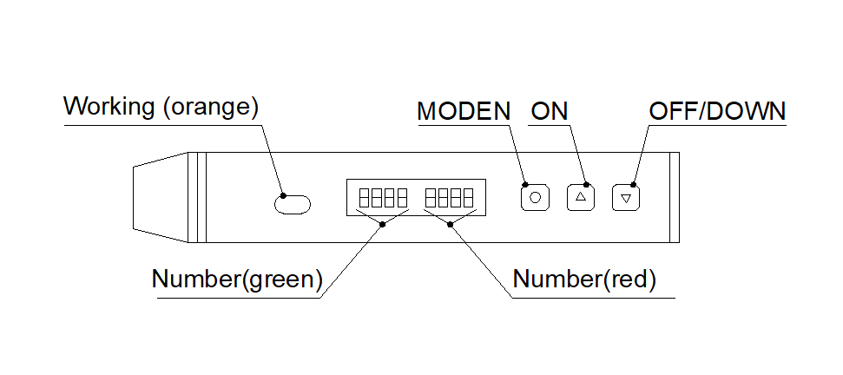

- The red number is the current detection value, and the green is the threshold. Press ON to increase the threshold, and OFF to decrease the threshold.
- The photoelectric adjustment method of the detection product: the red value shows XXX when the product is detected, and the red value shows YYY when the product is detected. Adjust the threshold value to make XXX>threshold>YYY.
- Detection label photoelectric adjustment method: the red value shows XXX when the label is detected, and the red value shows YYY when the bottom paper is detected. Adjust the threshold size to make XXX<threshold<YYY.

Part 10 Circuit wiring diagram （figure 4）
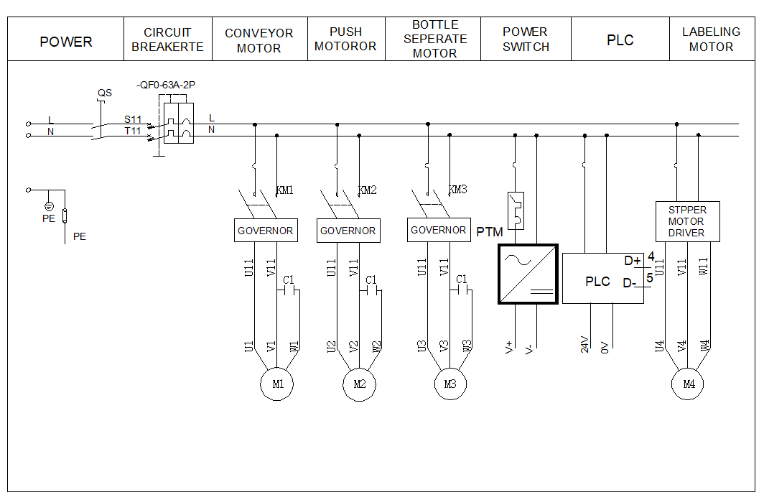
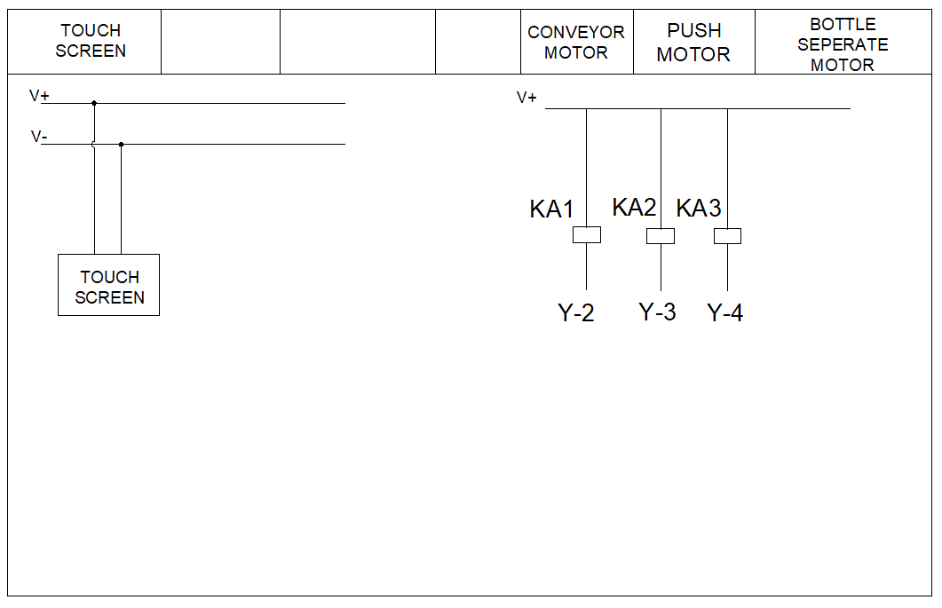
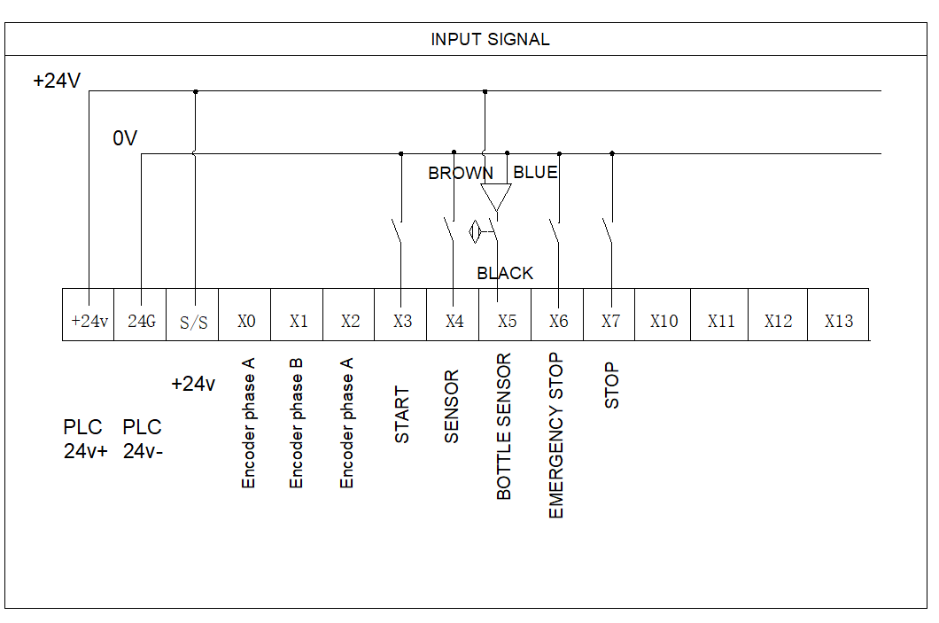
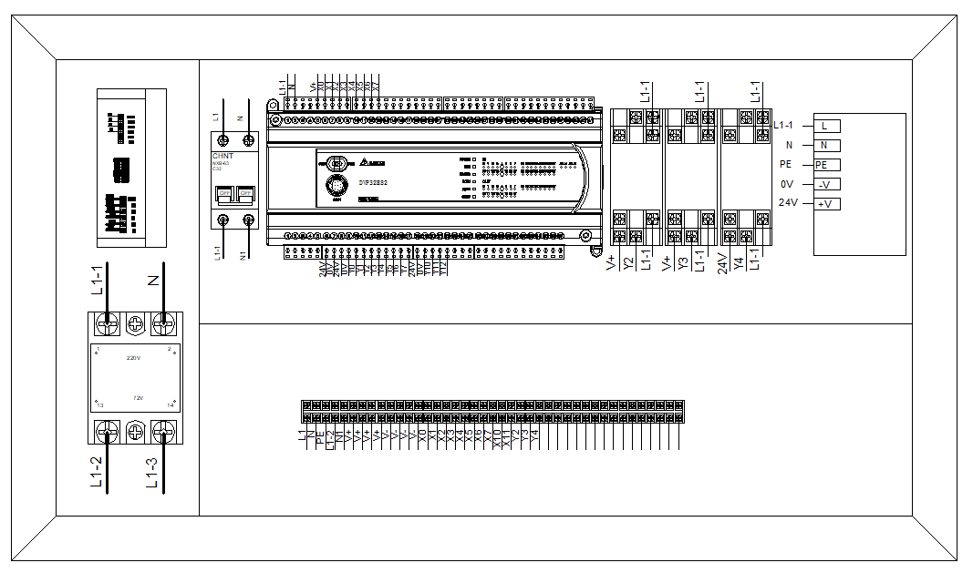
Part 11 Common problem and solution
Problem | Reason | Solution
Tags break constantly | Check the resistance of the brake and the pressure block and the depth of the label backing paper cutter to see if the backing paper has been cut. | Appropriately reduce the pressure resistance and replace the label.
Different lengths of label | Check whether the gap between the label and the label is consistent, whether the optical solder on the photoelectric bracket is loose, and whether the photoelectric amplifier is energized normally. | Replace the label, tighten the top wire of the fixed optical fiber, adjust the photoelectric sensitivity
Continuous labeling | Check whether the connection between the optical fiber and the amplifier is loose, whether the ordinary and time delay relays are damaged, and whether the surface of the optical fiber is scratched. Whether the photoelectric is damaged. | Tighten the optical solder, replace the relay, replace the amplifier and adjust the photoelectric sensitivity.
No label | Check whether the product trigger photoelectric, traction motor, and relay are damaged. | Replacement of relays, product inspection photoelectric and traction motors
In production, jitter occurs when labeling | Check the pressure resistance, check the pressing force of the embossing wheel, and check whether the driver is damaged | Reduce the pressure of the pressing block and the embossing wheel, and replace the driver
Sudden power failure of equipment during production | Check whether the power connector is loose, whether the external power supply is short-circuited, and check whether the fuse in the power switch is intact | Repair the power supply and replace the fuse
caveat! While debugging the equipment, the commissioning personnel must have basic power knowledge and must be familiar with this equipment manual. Dangerous operation and debugging can cause personal injury or death.
The above phenomenon is a relatively common problem. In the normal production process, if you encounter a problem that is not specified, please call the company's equipment after-sales technical department.

Part 12 Equipment maintenance
⑴ Packaging and transportation: When this equipment leaves the factory, it will be carefully debugged and rechecked according to the samples provided by the customer. After the commissioning and review are completed, the wooden packaging box will be tailored according to the overall size of the equipment. The whole equipment will be wrapped with plastic film, and the random accessories will be placed. Then carefully packing, fixing and sealing the box inside to complete the packaging. Transport by freight or internal trucks of the company.
- Maintenance: During the normal production of the equipment, pay attention to avoid production in an environment with excessive humidity or high temperature and dust. At the same time of each shift, clean and dry rags are used to wipe clean the external and internal dust of the equipment. Special attention should be paid to the photoelectric bracket to be cleaned in time. Otherwise, too much dust will cause poor sensitivity of the photoelectric amplifier, which will affect the labeling production. .
Part 13 Equipment main configuration list
name | Brand
Conveyor motor | Toho
Product inspection photoelectric | Panasonic
Label detection photoelectric | Panasonic
PLC | Delta
Touch screen | Delta
Stepper motor | Mitsubishi
Relay | Omron

